SULTAN SALEEM
WEEK 3 LAB TASK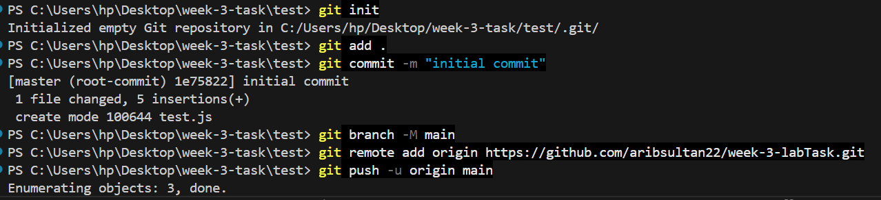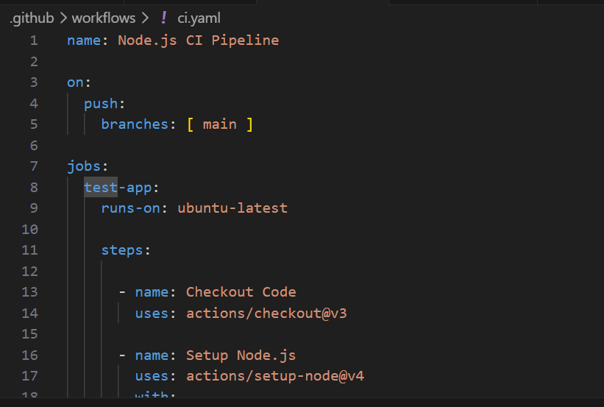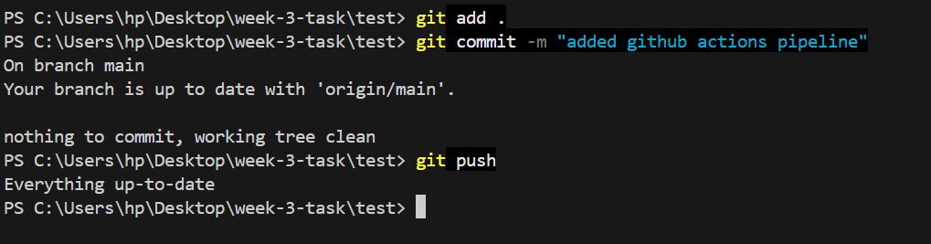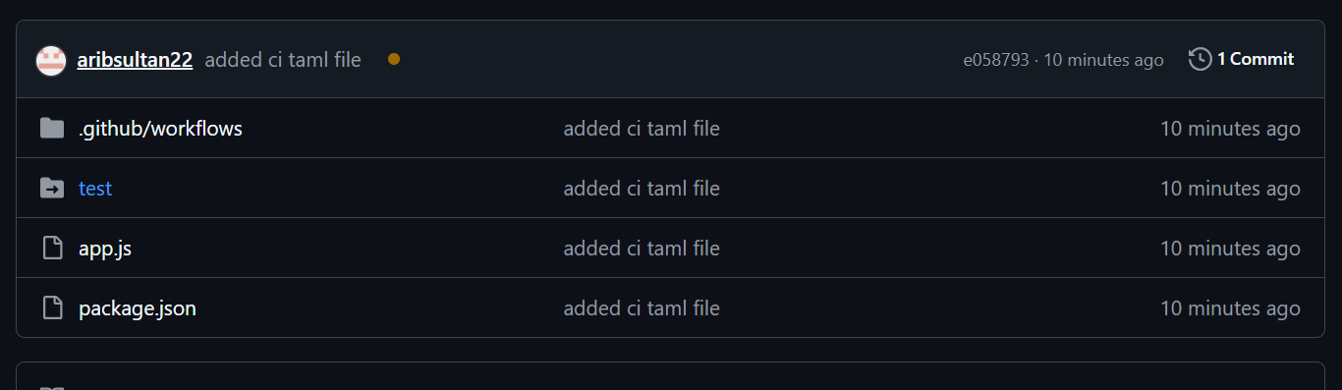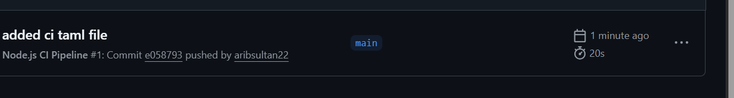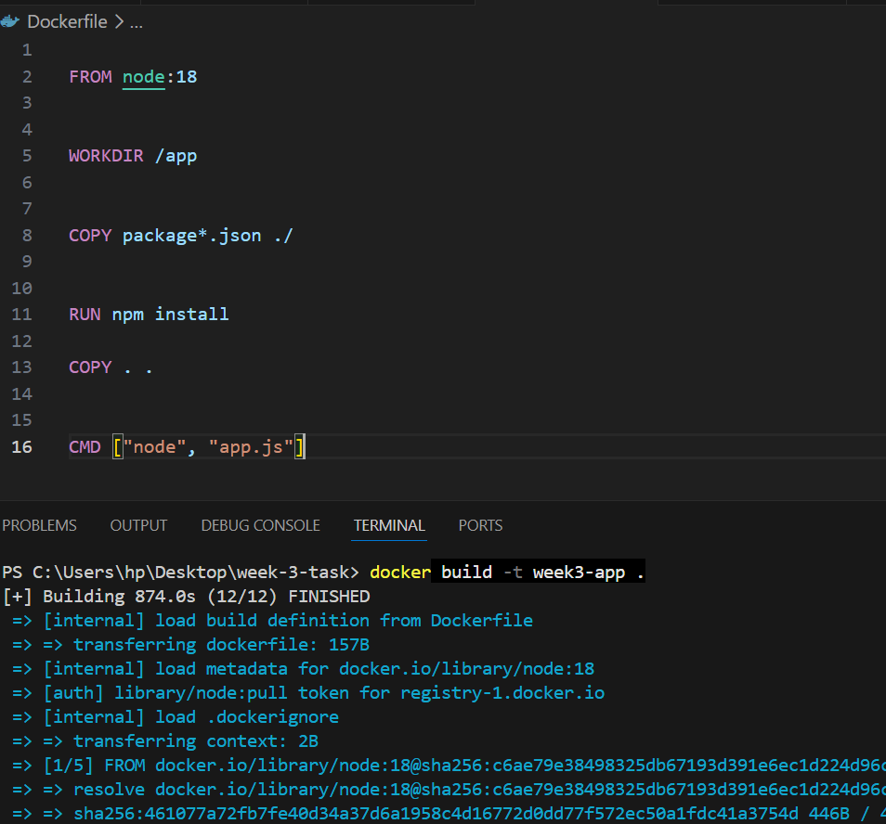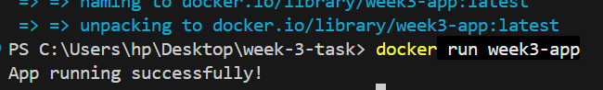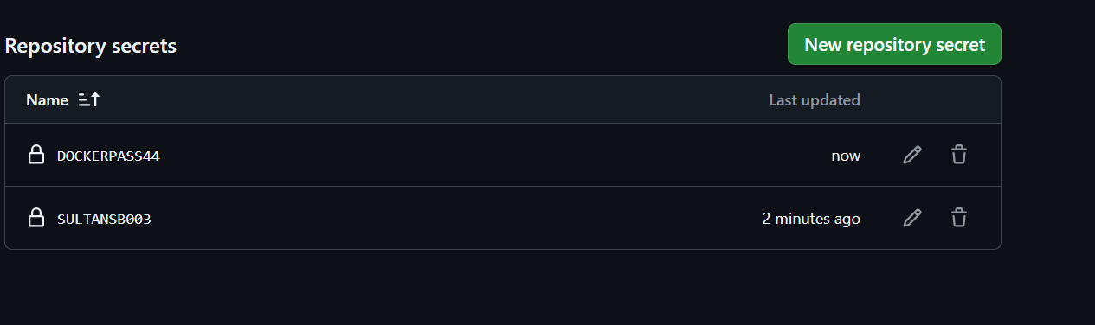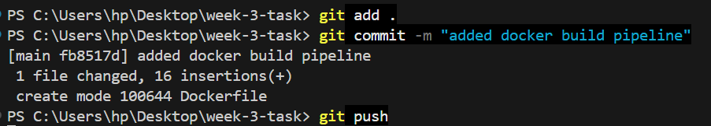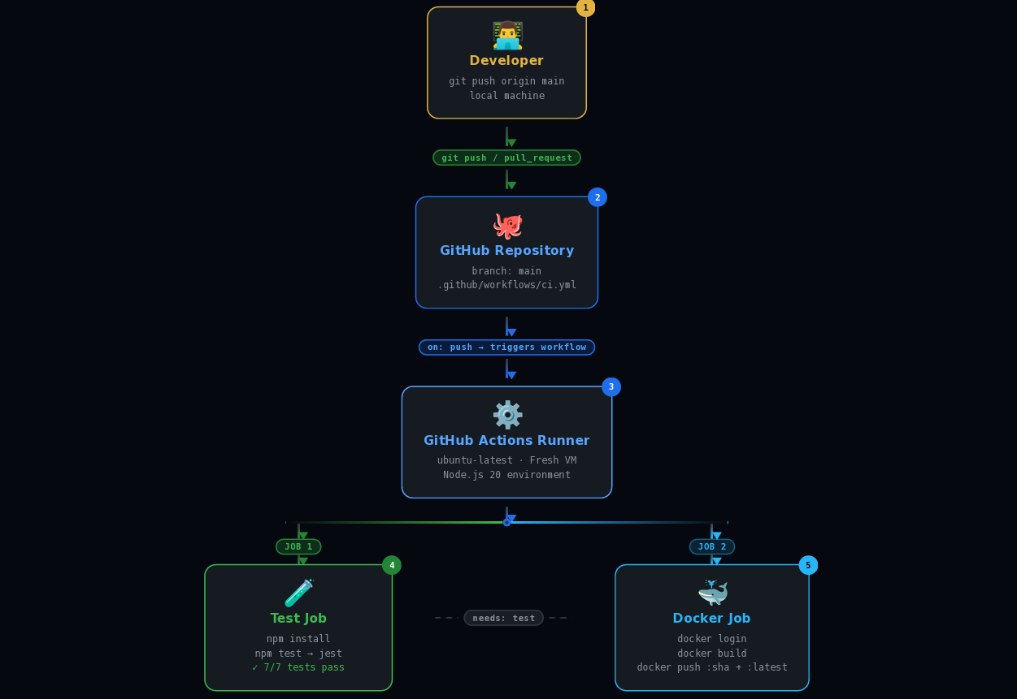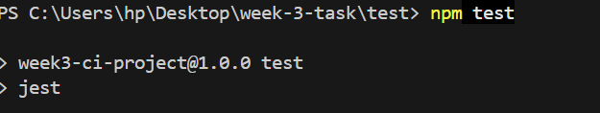

What is CI?
CI (Continuous Integration): Merging code changes into a central repository, followed by automated builds and tests to detect issues early.
What is CD?
CD (Continuous Deployment/Delivery): Automatically deploying code changes to production or staging environments after passing CI checks.
How GitHub Actions work?
GitHub Actions
GitHub Actions automate workflows in response to events (e.g., push, pull requests). They run on GitHub's servers, executing tasks like:
Building and testing code
Deploying to production
Sending notifications
Workflows are defined in YAML files in .github/workflows directory.

